SCREEN – SHOTS

1. LOGIN FORM:

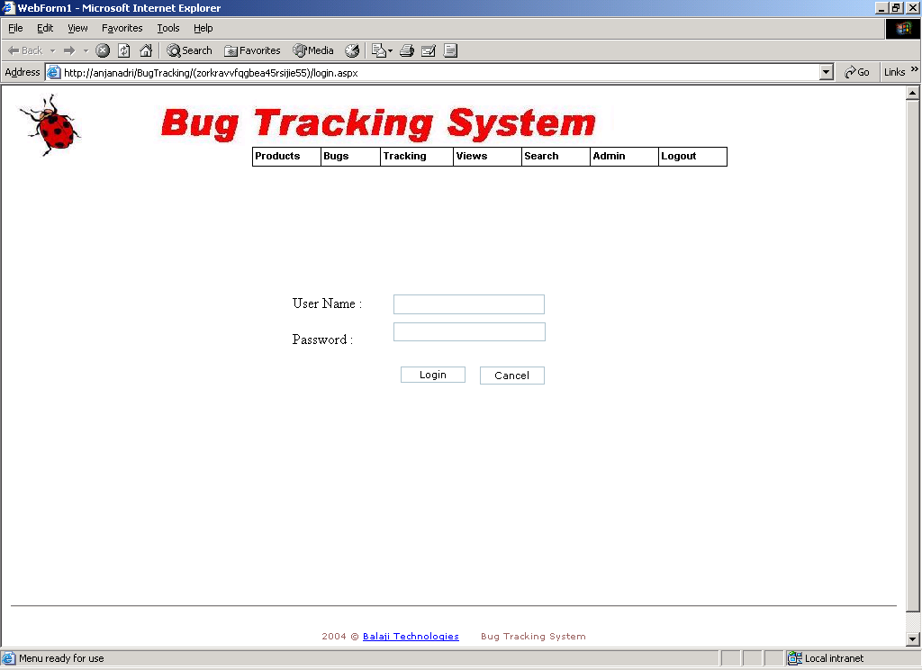
MENUS

1. PRODUCTS
1. PRODUCT DETAILS

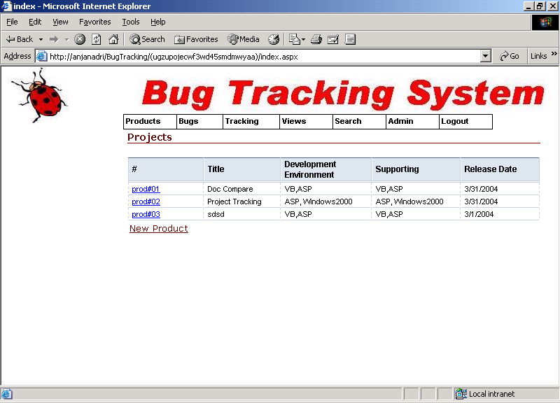

ADD PRODUCT DETAILS

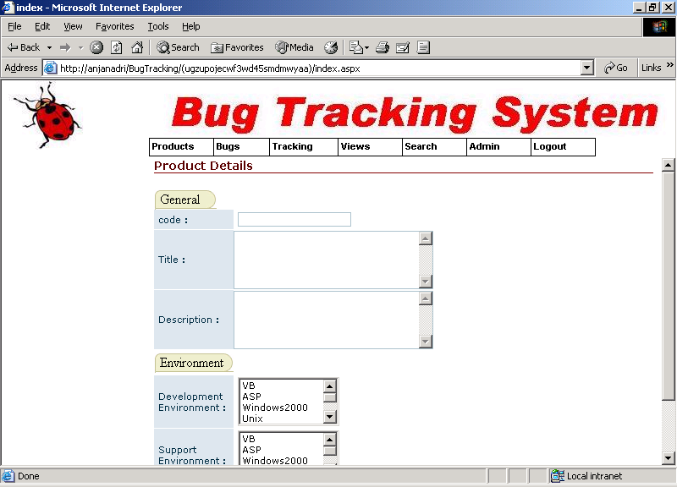

EDIT PRODUCT DETAILS

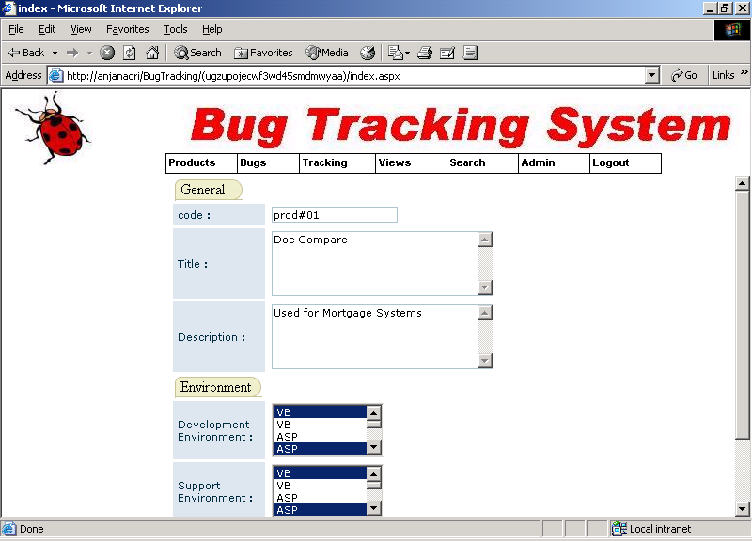

2. PRODUCT VERSION

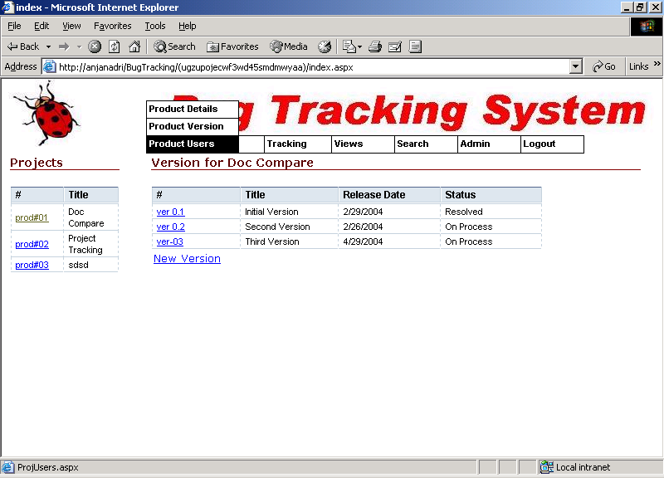

ADD PROJECT VERSION DETAILS

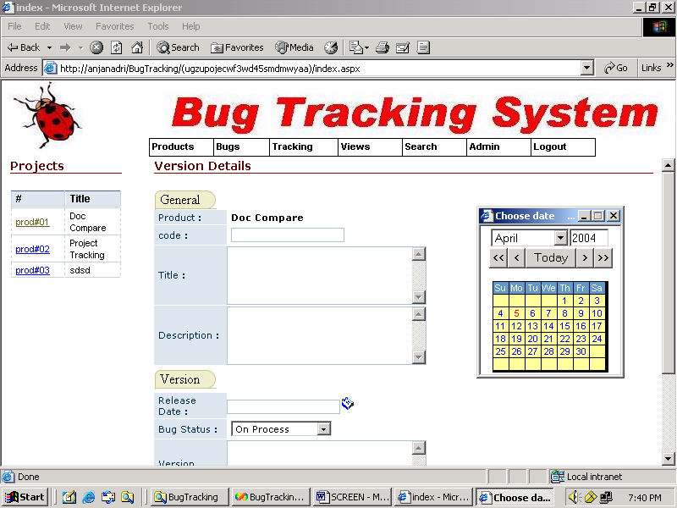

MODIFY PROJECT VERSION DETAILS

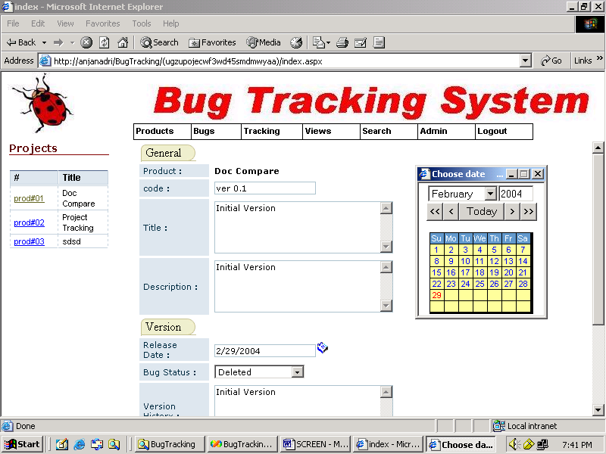

3. PRODUCT USERS

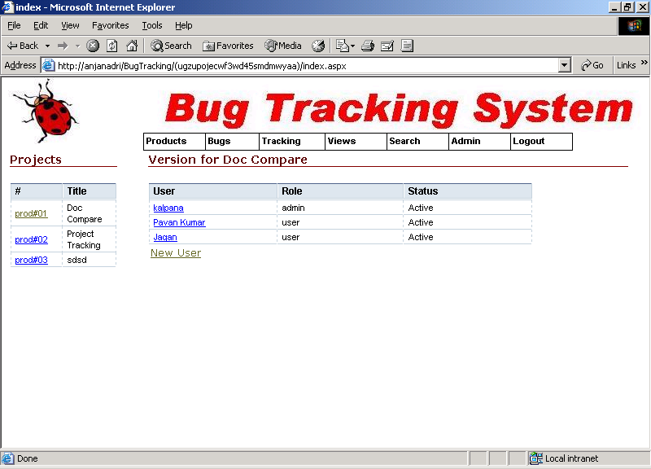

ADD NEW USER

MODIFY USER

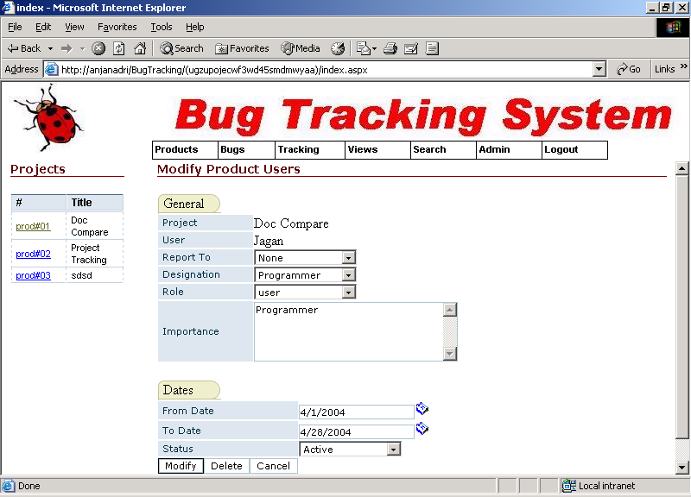
2.BUGS

1.BUG DETAILS

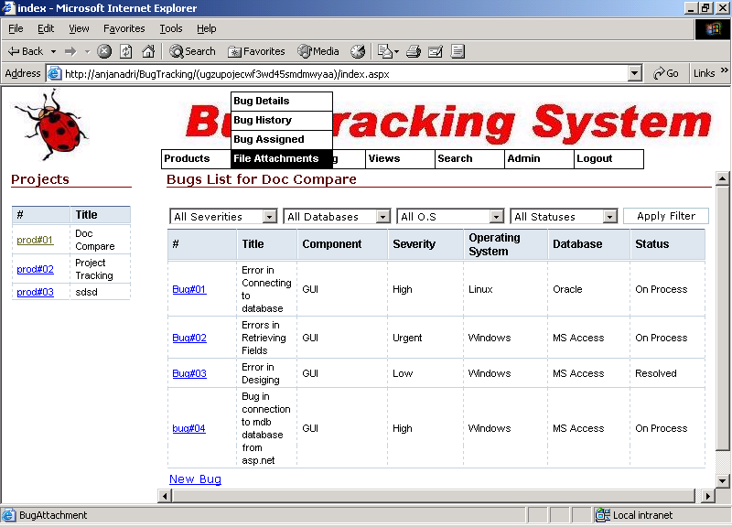
1. ADD BUG DETAILS

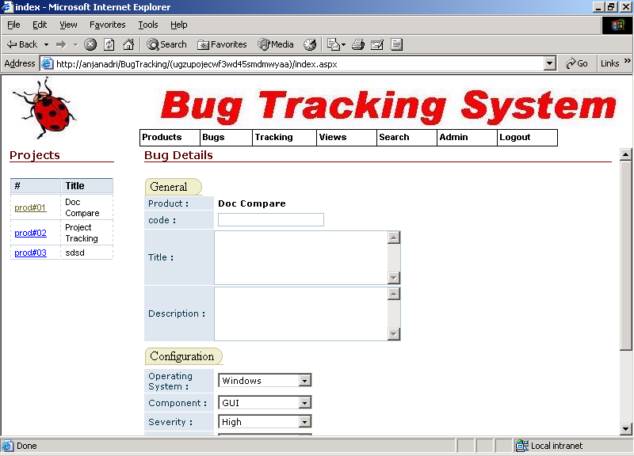

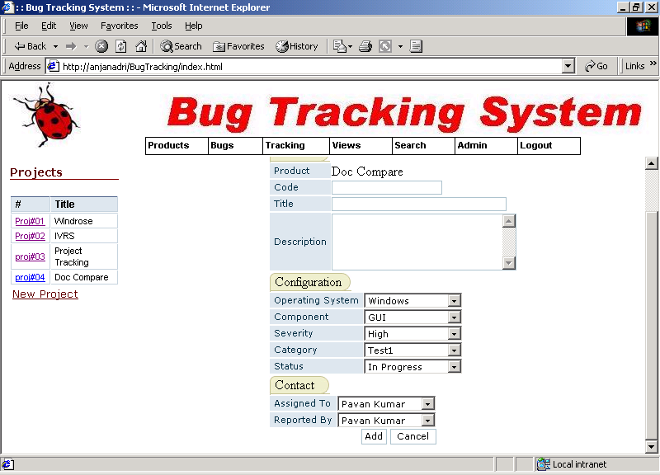

3. BUG ASSIGNED

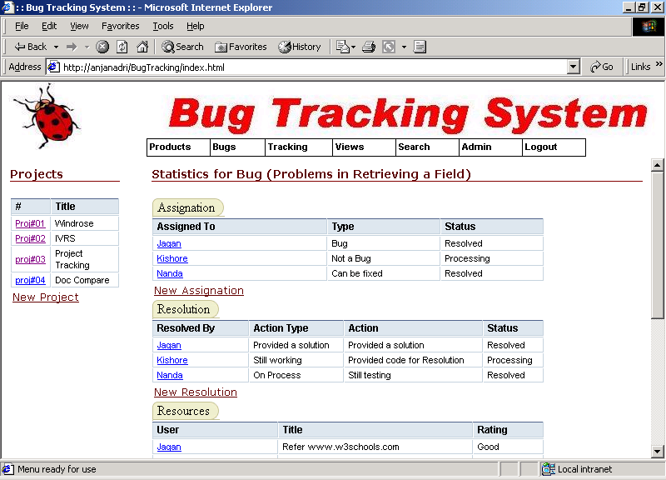

ASSIGNING BUG TO USER

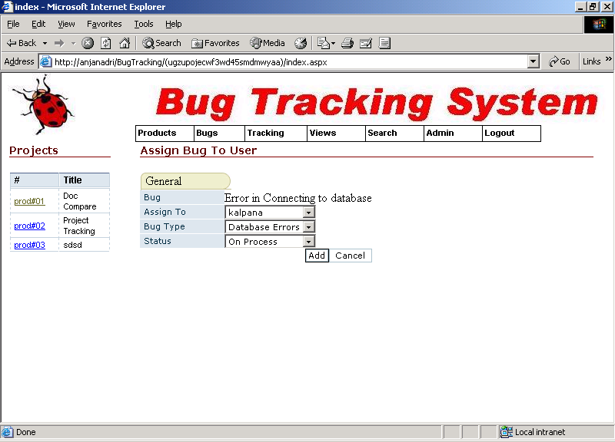

MODIFY BUG ASSIGNED TO USER

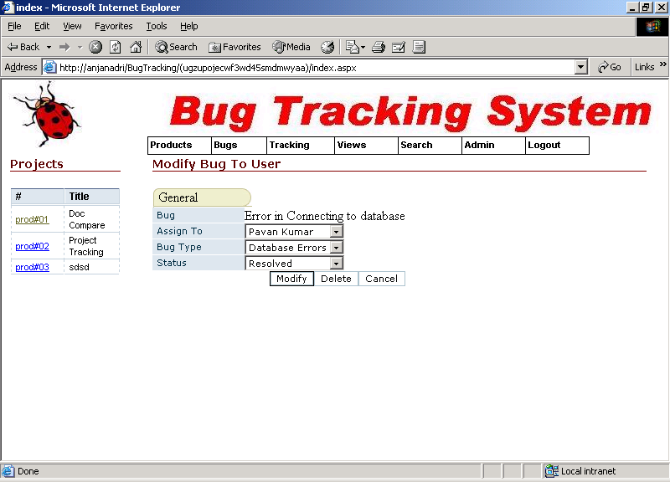

4. FILE ATTATCHMENTS

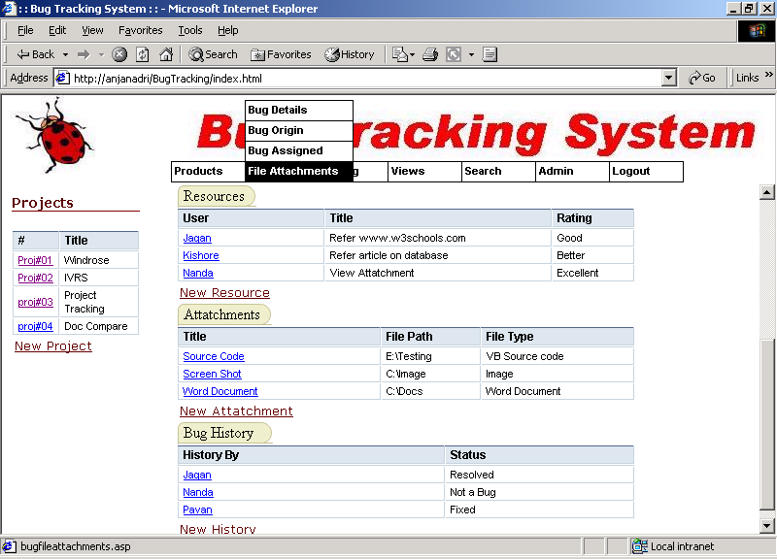

ADD NEW FILE ATTATCHMENT

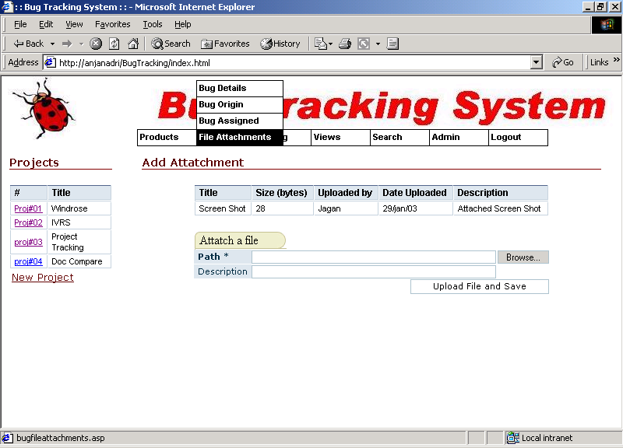

MODIFY FILE ATTATCHED

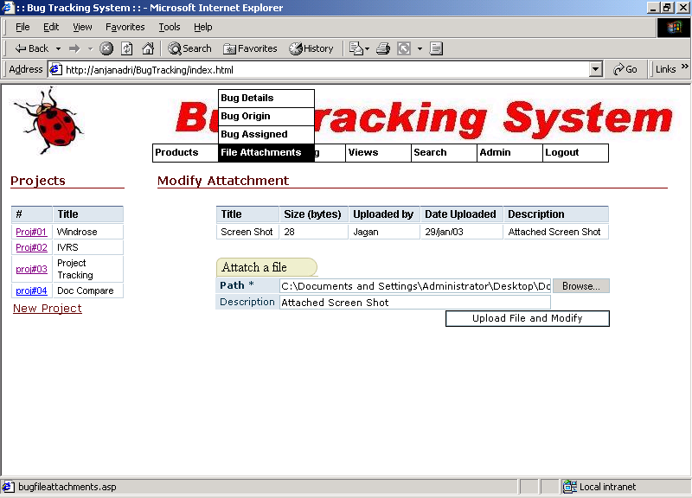

3. TRACKING

TRACK HIERARCHY

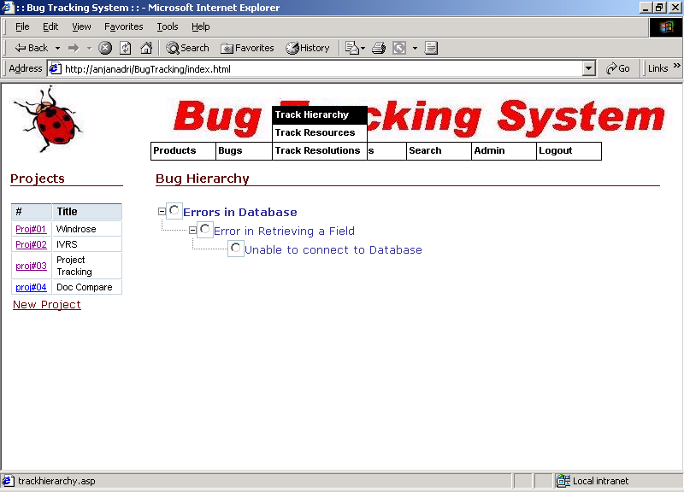

2. TRACK RESOURCES
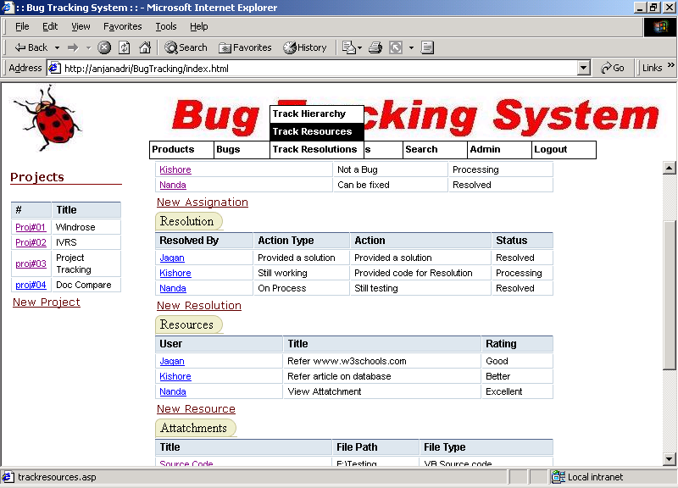

ADD NEW RESOURCE TO BUG

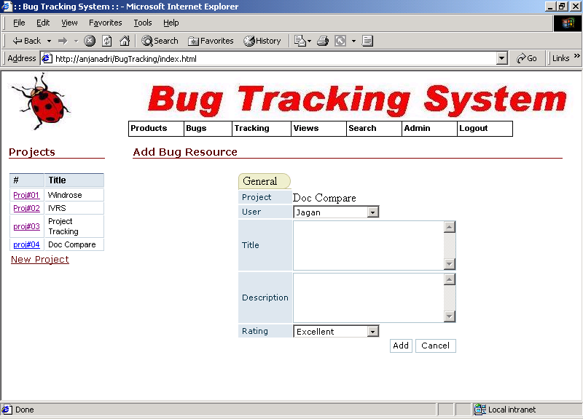

MODIFY EXISTING RESOURCE

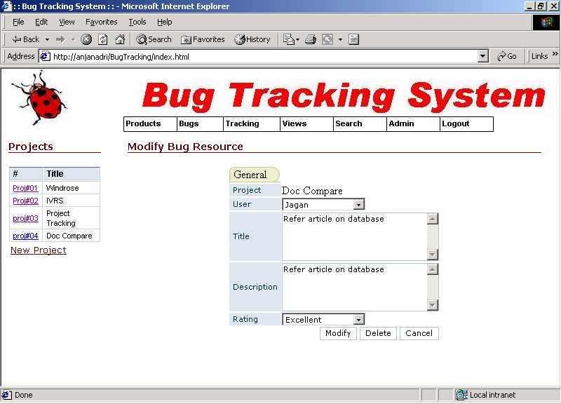

TRACK RESOLUTION

ADD NEW RESOLUTION

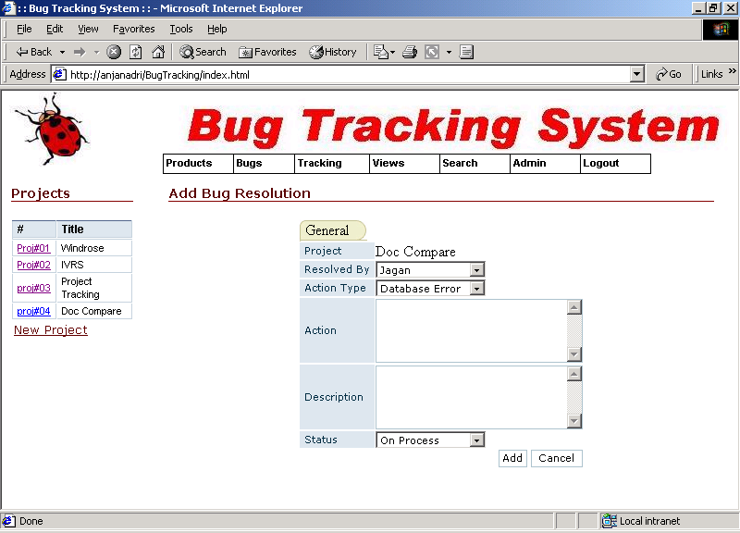

4. VIEWS

PRODUCT USER HIERARCHY

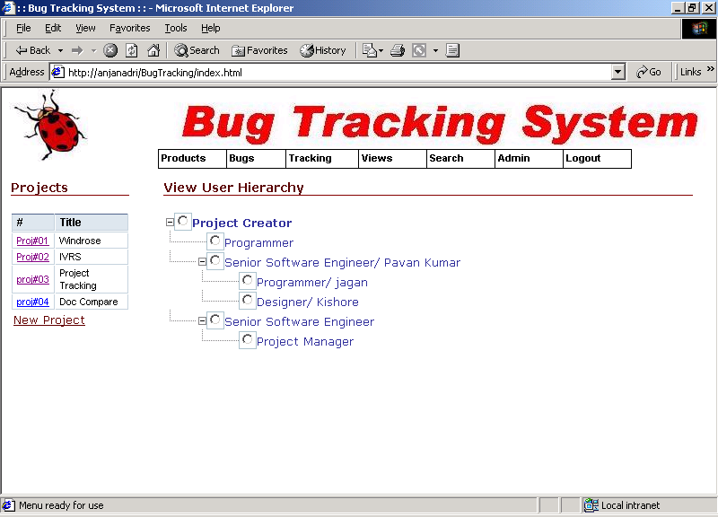

PRODUCT BUG HIERARCHY

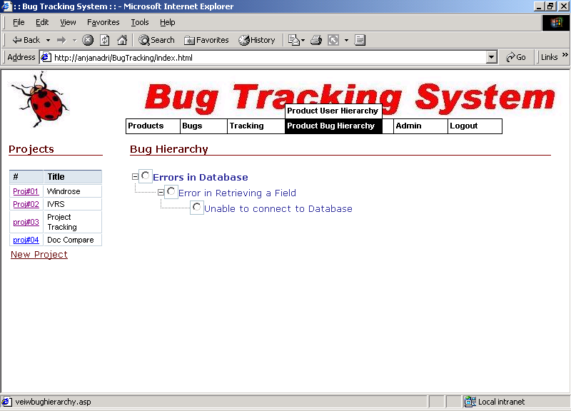

5. SEARCH

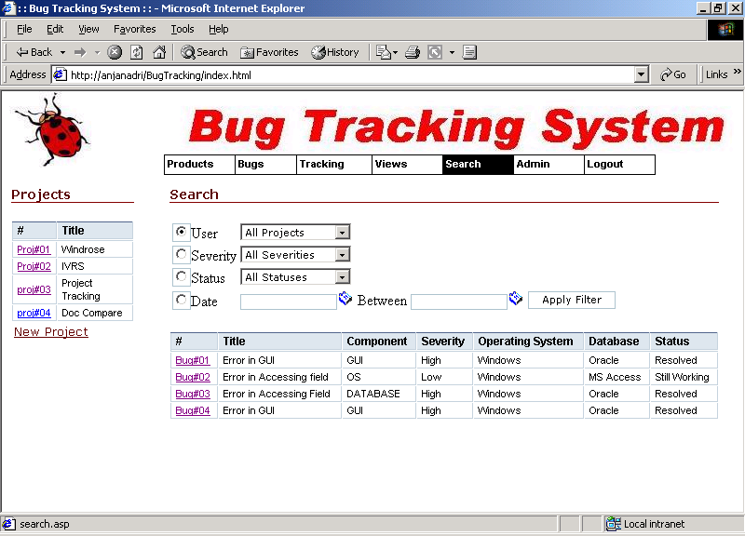

6. ADMIN

USER
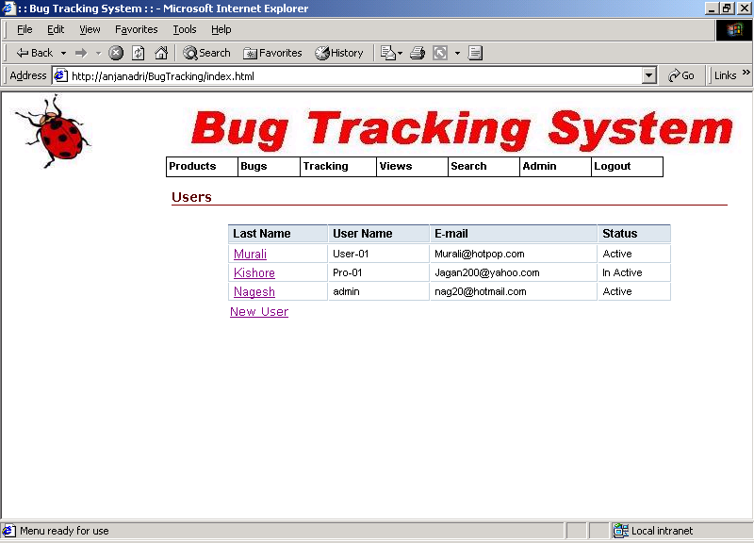

ADD NEW USER

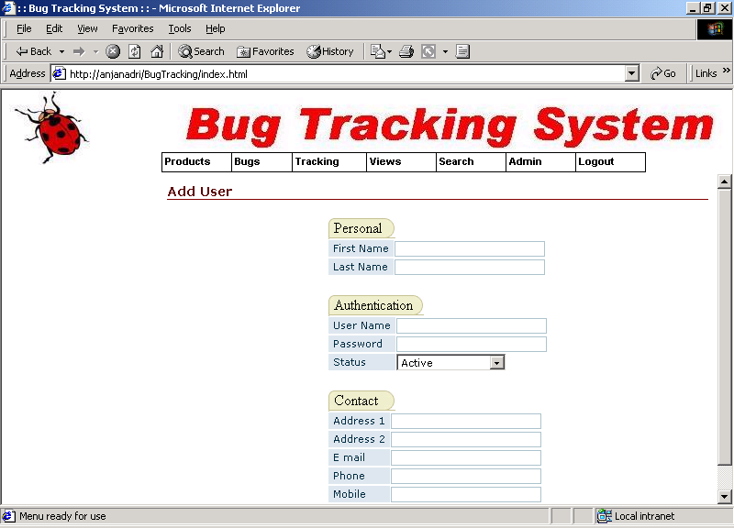

CONFIGURATION

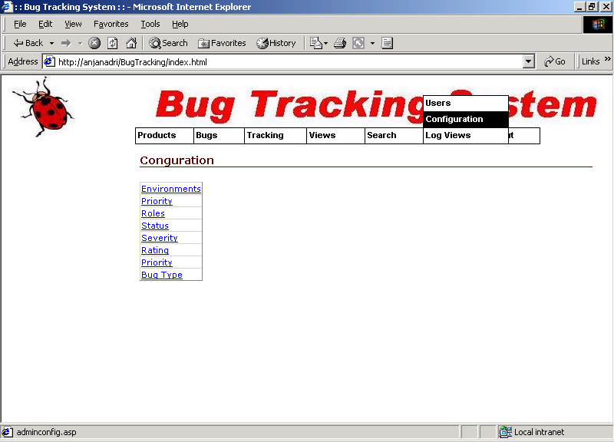

LOG

